Mercedes-Benz Greener Manufacturing

## MainCode

# Step1: Import the required libraries import numpy as np

import pandas as pd

from sklearn.decomposition import PCA

# Step2: Read the data from train.csv df_train = pd.read_csv('train.csv')

print('Size of training set: {} rows and {} columns'

.format(*df_train.shape)) df_train.head()

# Step3: Collect the Y values into an array y_train = df_train['y'].values

# Step4: Understand the data types we have cols = [c for c in df_train.columns if 'X' in c] print('Number of features: {}'.format(len(cols))) print('Feature types:') df_train[cols].dtypes.value_counts()

# Step5: Count the data in each of the columns counts = [[], [], []]

for c in cols:

typ = df_train[c].dtype

uniq = len(np.unique(df_train[c])) if uniq == 1:

counts[0].append(c)

elif uniq == 2 and typ == np.int64: counts[1].append(c)

else:

counts[2].append(c)

print('Constant features: {} Binary features: {} Categorical features: {}\n'

.format(*[len(c) for c in counts])) print('Constant features:', counts[0]) print('Categorical features:', counts[2])

# Step6: Read the test.csv data df_test = pd.read_csv('test.csv')

usable_columns = list(set(df_train.columns) - set(['ID', 'y'])) y_train = df_train['y'].values

id_test = df_test['ID'].values x_train = df_train[usable_columns] x_test = df_test[usable_columns]

# Step7: Check for null and unique values for test and train sets def check_missing_values(df):

if df.isnull().any().any():

print("There are missing values in the dataframe") else:

print("There are no missing values in the dataframe")

check_missing_values(x_train) check_missing_values(x_test)

# Step8: If for any column(s), the variance is equal to zero,

# then you need to remove those variable(s) and Apply label encoder for column in usable_columns:

cardinality = len(np.unique(x_train[column])) if cardinality == 1:

x_train.drop(column, axis=1) # Column with only one # value is useless so we drop it

x_test.drop(column, axis=1)

if cardinality > 2: # Column is categorical

mapper = lambda x: sum([ord(digit) for digit in x]) x_train[column] = x_train[column].apply(mapper) x_test[column] = x_test[column].apply(mapper)

x_train.head()

# Step9: Make sure the data is now changed into numericals print('Feature types:')

x_train[cols].dtypes.value_counts()

# Step10: Perform dimensionality reduction n_comp = 12

pca = PCA(n_components=n_comp, random_state=420) pca2_results_train = pca.fit_transform(x_train) pca2_results_test = pca.transform(x_test)

# Step11: Training using xgboost import xgboost as xgb

from sklearn.metrics import r2_score

from sklearn.model_selection import train_test_split

x_train, x_valid, y_train, y_valid = train_test_split( pca2_results_train,

y_train, test_size=0.2, random_state=4242)

d_train = xgb.DMatrix(x_train, label=y_train) d_valid = xgb.DMatrix(x_valid, label=y_valid) #d_test = xgb.DMatrix(x_test)

d_test = xgb.DMatrix(pca2_results_test)

params = {}

params['objective'] = 'reg:linear' params['eta'] = 0.02

params['max_depth'] = 4

def xgb_r2_score(preds, dtrain): labels = dtrain.get_label()

return 'r2', r2_score(labels, preds)

watchlist = [(d_train, 'train'), (d_valid, 'valid')]

clf = xgb.train(params, d_train,

1000, watchlist, early_stopping_rounds=50, feval=xgb_r2_score, maximize=True, verbose_eval=10)

# Step12: Predict your test_df values using xgboost p_test = clf.predict(d_test)

sub = pd.DataFrame() sub['ID'] = id_test sub['y'] = p_test

sub.to_csv('xgb.csv', index=False) sub.head()

################################################################ ######

''' End '''

# Code Snippet followed a Screenshot of the Output

## Q1. Read the data from train.csv and Collect the Y values into an array

# Step2: Read the data from train.csv

df_train = pd.read_csv('train.csv') # let us understand the data

print('Size of training set: {} rows and {} columns'

.format(*df_train.shape))

# print few rows and see how the data looks like df_train.head()

# Step3: Collect the Y values into an array

# seperate the y from the data as we will use this to learn as # the prediction output

y_train = df_train['y'].values

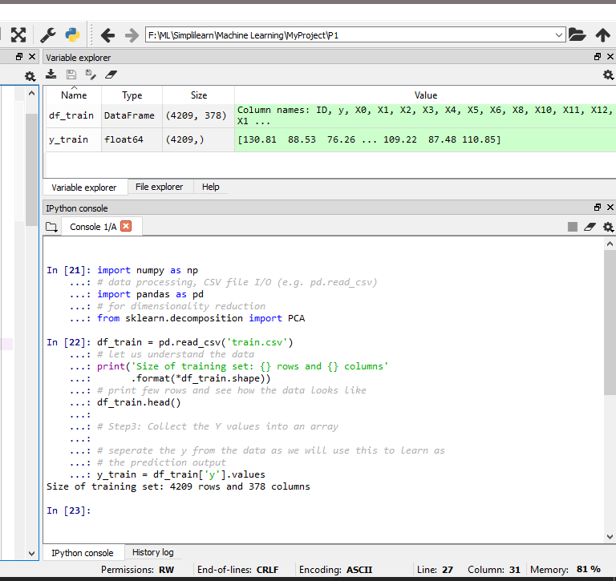

## Q2. Understand the data types we have and Count the data in each of the columns

# Step4: Understand the data types we have

# iterate through all the columns which has X in the name of the column

cols = [c for c in df_train.columns if 'X' in c] print('Number of features: {}'.format(len(cols)))

print('Feature types:') df_train[cols].dtypes.value_counts()

# Step5: Count the data in each of the columns

counts = [[], [], []] for c in cols:

typ = df_train[c].dtype

uniq = len(np.unique(df_train[c])) if uniq == 1:

counts[0].append(c)

elif uniq == 2 and typ == np.int64: counts[1].append(c)

else:

counts[2].append(c)

print('Constant features: {} Binary features: {} Categorical features:

{}\n'

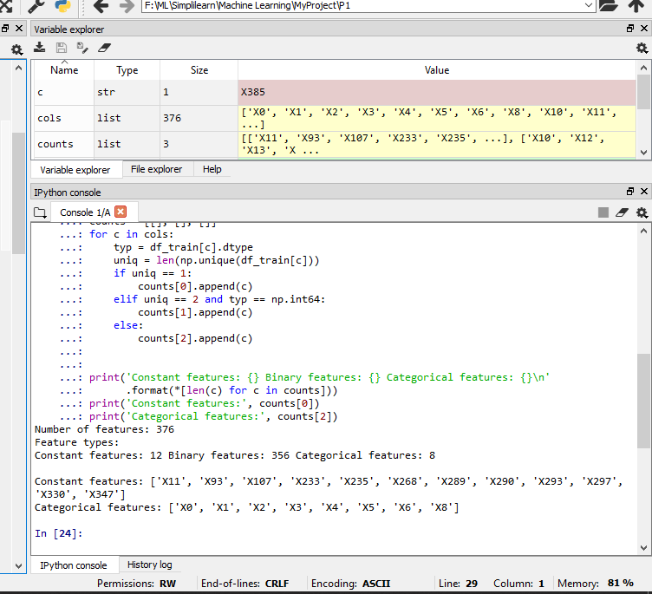.format(*[len(c) for c in counts])) print('Constant features:', counts[0]) print('Categorical features:', counts[2])

## Q3. Read the test.csv data and Check for null and unique values for test and train sets

# Step6: Read the test.csv data

df_test = pd.read_csv('test.csv')

# remove columns ID and Y from the data as they are not used for learning

usable_columns = list(set(df_train.columns) - set(['ID', 'y'])) y_train = df_train['y'].values

id_test = df_test['ID'].values

x_train = df_train[usable_columns] x_test = df_test[usable_columns]

# Step7: Check for null and unique values for test and train sets

def check_missing_values(df):

if df.isnull().any().any():

print("There are missing values in the dataframe")

else:

print("There are no missing values in the dataframe")

check_missing_values(x_train) check_missing_values(x_test)

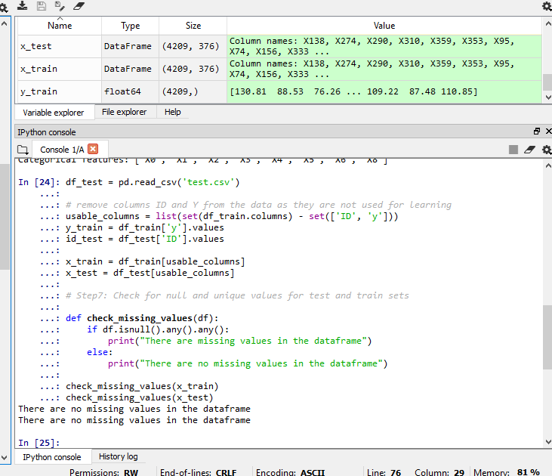

## Q4. If for any column(s), the variance is equal to zero, then you need to remove those variable(s) and Apply label encoder

# Step8: If for any column(s), the variance is equal to zero, # then you need to remove those variable(s).

# Apply label encoder

for column in usable_columns:

cardinality = len(np.unique(x_train[column])) if cardinality == 1:

x_train.drop(column, axis=1) # Column with only one # value is useless so we drop it

x_test.drop(column, axis=1)

if cardinality > 2: # Column is categorical

mapper = lambda x: sum([ord(digit) for digit in x]) x_train[column] = x_train[column].apply(mapper) x_test[column] = x_test[column].apply(mapper)

x_train.head()

# Step9: Make sure the data is now changed into numericals

print('Feature types:') x_train[cols].dtypes.value_counts()

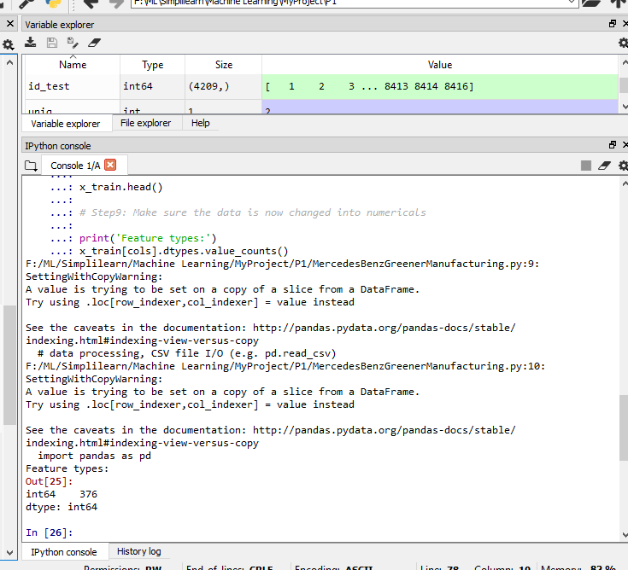

## Q5. Perform dimensionality reduction

# Step10: Perform dimensionality reduction

# Linear dimensionality reduction using Singular Value Decomposition of # the data to project it to a lower dimensional space.

n_comp = 12

pca = PCA(n_components=n_comp, random_state=420) pca2_results_train = pca.fit_transform(x_train) pca2_results_test = pca.transform(x_test)

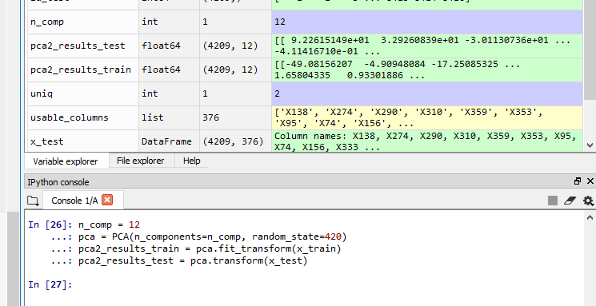

## Q6. Training using xgboost

# Step11: Training using xgboost

import xgboost as xgb

from sklearn.metrics import r2_score

from sklearn.model_selection import train_test_split

x_train, x_valid, y_train, y_valid = train_test_split( pca2_results_train,

y_train, test_size=0.2, random_state=4242)

d_train = xgb.DMatrix(x_train, label=y_train) d_valid = xgb.DMatrix(x_valid, label=y_valid)

#d_test = xgb.DMatrix(x_test)

d_test = xgb.DMatrix(pca2_results_test)

params = {} params['objective'] = 'reg:linear' params['eta'] = 0.02

params['max_depth'] = 4

def xgb_r2_score(preds, dtrain): labels = dtrain.get_label()

return 'r2', r2_score(labels, preds)

watchlist = [(d_train, 'train'), (d_valid, 'valid')]

clf = xgb.train(params, d_train,

1000, watchlist, early_stopping_rounds=50, feval=xgb_r2_score, maximize=True,

verbose_eval=10)

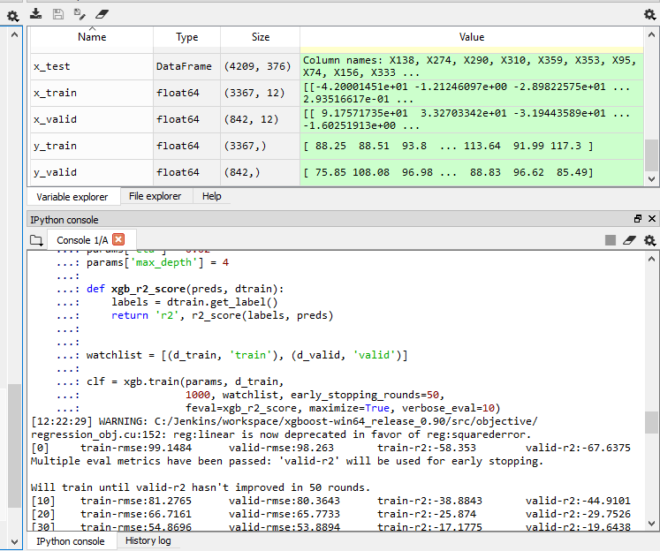

## Q7. Predict your test_df values using xgboost

p_test = clf.predict(d_test)

sub = pd.DataFrame() sub['ID'] = id_test sub['y'] = p_test

sub.to_csv('xgb.csv', index=False)

sub.head()

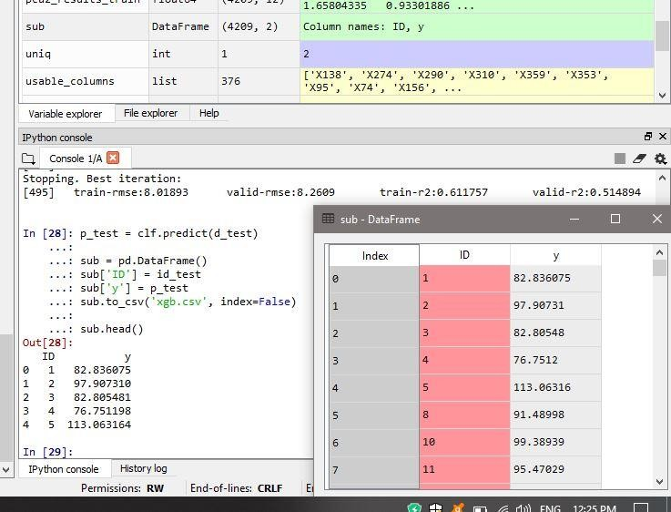

# ***End***